**TOP CLASS LESSON NOTES TERM I**

**LEARNING AREA 3 (HEALTH HABITS)**

**Topics to be covered in term one**

* **Body parts**
* **Body senses**
* **Things used to clean our bodies**
* **Things we wear**
* **Things that harm our bodies (dangerous objects)**
* **Food we eat**
* **Fruits we eat**
* **Sources of light**

**Learning out:**

**Caring for the body**

**WEEK ONE**

**Activity 1**

**Name the body parts**

|  |  |  |
| --- | --- | --- |
|  |  |  |
|  |  |  |
|  |  |  |
|  |  |  |

**Activity 2**

**Name these body parts**

|  |  |  |
| --- | --- | --- |
|  |  |  |
|  |  |  |
|  |  |  |
|  |  |  |

**Tick the same words.**

mouth mat mouth

finger finger skirt

back back tie

ten teeth teeth

**Activity 3**

**Match the same words.**

teeth lips

head chin

tongue teeth

leg head

chin leg

lips tongue

**Activity 4**

**Fill in the missing letters**

t-----ngue te-----th ey----s l -----ps n-----se l ------g

**Activity 5**

**Fill in the missing letter**

he----d ch----n e----r b---ck kn-----es h ----nd

**WEEK 2**

**Body uses**

**Activity 1**

**Match the same words**

seeing tasting

hearing smelling

touching walking

feeling seeing

walking hearing

smelling touching

tasting feeling

**Activity 2**

**Complete correctly.**

I use my eyes for ------

I use my ears for -----

I use my nose for -----

I use my leg for ------

I use my fingers for -----

I use my skin for ------

**Activity 3**

**Match the body part to its use.**

skin hearing

finger tasting

nose walking

eyes feeling

legs touching

tongue smelling

ears seeing

**Activity 4**

**Circle its use**

ears smelling hearing

eyes touching seeing

skin feeling cooking

legs jumping walking

nose smelling tasting

**Activity 5**

**Fill in the missing letter**

f___ ___ling w___lking t___sting

sm____lling t____uching se___ing

**WEEK 3**

**Things used to clean our body**

**Activity 1**

**Read and draw**

|  |  |  |  |  |  |
| --- | --- | --- | --- | --- | --- |
| Soap | Brush | Comb | Towel | Water | toothbrush |
|  |  |  |  |  |  |

**Activity 2**

**Circle the correct words for the picture**

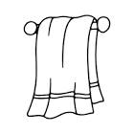 cup sponge towel

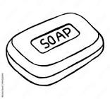 water tin soap

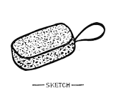 book sponge ball

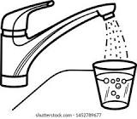 tin cup water

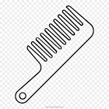 comb soap towel

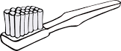 ball toothbrush brush

**Activity 3**

**Name these things used to clean our body.**

|  |  |  |
| --- | --- | --- |
|  |  |  |
|  |  |  |
|  |  |  |
|  |  |  |

**Activity 4**

**Match a picture to a word.**

 brush

 comb

 soap

 tooth brush

 towel

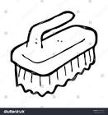 sponge

**Activity 5**

**Read and draw**

|  |  |  |
| --- | --- | --- |
| Towel | Tooth paste | Sponge |
| Comb | Water | Soap |

**WEEK 4**

**Dangerous objects**

**Activity 1**

**Circle the same words.**

fire fire mat

razorblade tin razorblade

wall pin pin

broken bottle cup broken bottle

stick stick mat

hat stone stone

**Activity 2**

**Read and match**

Thorn 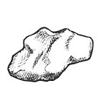

broken glass 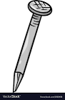

fire 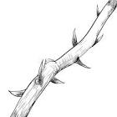

safety pin 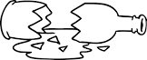

nail 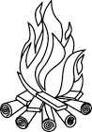

stone 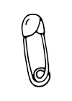

**Activity 3**

**Tick the correct word**

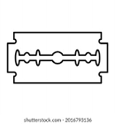 broken bottle razorblade

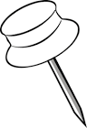 stick pin

 razorblade fire

 safety pin nail

 stick stone

 broken bottle pin

**Activity 4**

**Read and draw**

|  |  |  |
| --- | --- | --- |
| Pin | Broken bottle | Stone |
| Safety pin | Nail | Stick |

**Activity 5**

**Name these pictures**

|  |  |  |
| --- | --- | --- |
|  |  |  |
|  |  |  |

**WEEK 5**

**Things we wear**

**Activity 1**

**Name things we wear.**

|  |  |  |
| --- | --- | --- |
|  |  |  |
|  |  |  |
|  |  |  |
|  |  |  |

**Activity 2**

**Tick the correct word for a picture**

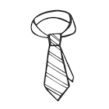 tie short

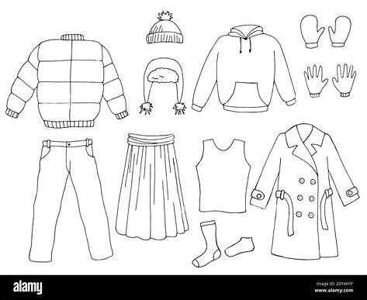 sweater axe

 tin shirt

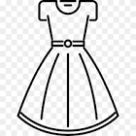 dress dog

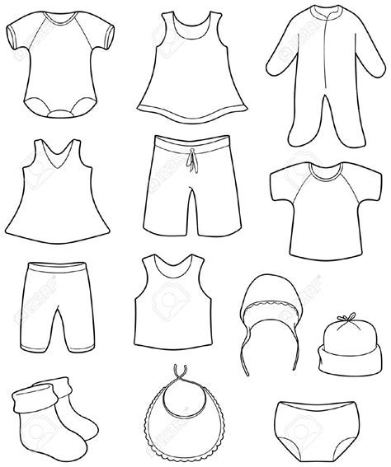 hat short

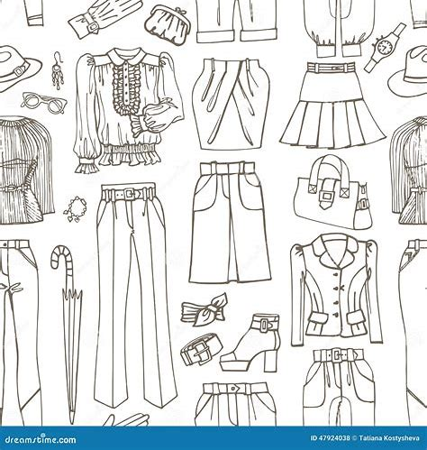 trousers dress

**Activity 3**

**Read and draw**

|  |  |  |
| --- | --- | --- |
| Trouser | Dress | Skirt |
| Tie | Jacket | Hat |

**Activity 4**

**Read and draw**

|  |  |  |
| --- | --- | --- |
| Short | Sweater | Shirt |
| Belt | Shoe | Trouser |

**Activity 5**

**Fill in the missing letter**

tr---usser sho----t h---t

dr----ss b---lt sh----e

**WEEK 6**

**Learning out come:**

**Using my sense of taste and caring for the mouth.**

**Activity 1**

**Fruits we eat**

**Name these fruits we eat.**

|  |  |  |
| --- | --- | --- |
|  |  |  |
|  |  |  |
|  |  |  |
|  |  |  |

**Activity 2**

**Read and draw.**

|  |  |  |
| --- | --- | --- |
| Jackfruit | Mango | Apple |
| Pineapple | Orange | Yellow banana |

**Activity 3**

**Read and draw**

|  |  |  |
| --- | --- | --- |
| Tomato | Carrot | Sugarcane |
| Pawpaw | Jack fruit | Pineapple |

**Activity 4**

**Fill in the missing letter**

carr----t t---mato ba----ana

y-----llow banana or-----nge m-----ngo

**Activity 5**

**Fill in the missing letter**

j----ckfruit a--- ----le p----ne apple

or----nge c----rrot m-----ngo

**WEEK 7**

**Food we eat**

**Read and draw**

|  |  |  |
| --- | --- | --- |
| Meat | Fish | chicken |
| Yam | Rice | Beans |

**Activity 2**

**Read and draw**

|  |  |  |
| --- | --- | --- |
| Maize | Cassava | Sweet potatoes |
| Eggs | Irish |

**Activity 3**

**Name the pictures**

|  |  |  |
| --- | --- | --- |
|  |  |  |
|  |  |  |
|  |  |  |
|  |  |  |

**Activity 4**

**Tick the same words.**

sweet potatoes irish sweet potatoes

egg egg ehe

shop maize maize

cassava cassava tin

soap fish fish

**Activity 5**

**Read and draw**

|  |  |  |
| --- | --- | --- |
| Maize | Matooke | Meat |
| Rice | Milk | Cassava |